Hive Installation on Ubuntu:

Please follow the below steps to install Apache Hive on Ubuntu:

Download tar file of Hive

http://archive.apache.org/dist/hive/hive-2.1.0/

Extract and store in home folder

Step 3: Edit the “.bashrc” file to update the environment variables for user.

sudo gedit ~/.bashrc

Add the following at the end of the file:

export Hive_INSTALL=/home/hadoop22/apache-hive-2.1.0-bin

export PATH=$PATH:$Hive_INSTALL/bin

Step 4:For the environment variables to be set as mentioned in the .bashrc file, the file needs to be sourced using the ‘source’ command-

source ~/.bashrc

Check hive version.
hive –version

Step 5: Create Hive directories within HDFS. The directory ‘warehouse’ is the location to store the table or data related to hive.

Command:

hadoop fs -mkdir -p /user/hive/warehouse

hadoop fs -mkdir /tmp

Step 5: Set read/write permissions for table.

Command:

In this command, we are giving write permission to the group:

hadoop fs -chmod g+w /user/hive/warehouse

hdfs dfs -chmod g+w /tmp

Step 6: For Hive to interact with Hadoop HDFS, it must know the path to the hadoop installation directory. This can be achieved by Setting HADOOP_PATH in HIVE config.sh

Commands

user@ubuntu:~$ cd apache-hive-2.1.0-bin/bin
user@ubuntu:~$ sudo gedit hive-config.sh

Go to the line where the following statements are written

# Allow alternate conf dir location.
HIVE_CONF_DIR="${HIVE_CONF_DIR:-$HIVE_HOME/conf"
export HIVE_CONF_DIR=$HIVE_CONF_DIR
export HIVE_AUX_JARS_PATH=$HIVE_AUX_JARS_PATH

Below this write the following

export HADOOP_HOME=/home/hadoop22/hadoop-2.7.5 (write the path where hadoop file is there)

Step 9

Having set the path, permissions and other configuration files, we are all set to launch the Hive shell

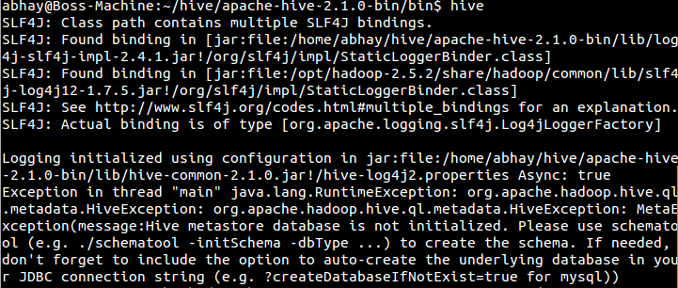

Oops!!! There seems to be an error while launching the Hive shell as we have not specified the name of the database Hive should use to store the metadata that will be used to reference raw data.

Now let’s inform hive about the database that it should use for its schema definition. The below command tells hive to use derby database as its metastore database. We can also specify this in the hadoop hive configuration file ‘hive-site.xml’ file.

$HIVE_HOME/bin/schematool –initschema –dbtype derby

Step 10 Start hive prompt

$HIVE_HOME/bin/hive

show databases;

create database anjali;
use anjali;

Create Internal Table

Internal tables are similar to your regular tables, deleting table will also delete schema & content.
But these tables will be stored in hdfs.
Either we can use insert command on internal table or file in local file system can be fed to table to load all content in table.

create table emp1(ename string, esal int) row format delimited fields terminated by ',' stored as textfile;

insert into table emp1 values('ABC',70000);

This will show you status of Map & reduce operation

OR

load data local inpath '/home/hadoop22/emptest.txt' into table emp1;

select * from emp1;

Location of this internal table will be /user/hive/warehouse/anjali.db/emp1 in hdfs file system

Create External Table

Actual HDFS data files exists outside of hive databases. Dropping external table in Hive does not drop the HDFS file that it is referring whereas dropping managed tables drop all its associated HDFS files.

Hive Create External Tables Syntax

CREATE EXTERNAL TABLE [IF NOT EXISTS] [db_name.] table_name
[(col_name data_type [COMMENT col_comment], ...)]
[COMMENT table_comment]
[ROW FORMAT row_format]
[FIELDS TERMINATED BY char]
[STORED AS file_format]
[LOCATION hdfs_path];

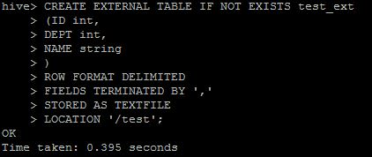

create external table emp2(ename string, esal int) row format delimited fields terminated by ',' stored as textfile location '/mytext';

no need to write load command

directly try select command

select * from emp2;

so both tables are present in HDFS only difference is that External table will be created on existing file present in hdfs so dropping table deletes only schema and not data. External table syntax takes location of file present in hdfs.

So no need to write load statement for external table

How to clear Hive Console / Screen?

Execute any of the following commands on Hive Console

!clear;

OR

CTRL + L

Error Message
Unable to initialize hive with Derby
Error: FUNCTION 'NUCLEUS_ASCII' already exists. (state=X0Y68,code=30000)
org.apache.hadoop.hive.metastore.HiveMetaException: Schema initialization FAILED! Metastore state would be inconsistent !!
Underlying cause: java.io.IOException : Schema script failed, errorcode 2
Use --verbose for detailed stacktrace.
*** schemaTool failed ***

Resolution:
Step- 1: Remove the metastore_db
[root@rh-mcnode01 ~]# cd $HIVE_HOME/conf/

[root@rh-mcnode01 ~]# mv metastore_db metastore_db.tmp

Step-2: Re-run the Metastore creation (from hive home/bin)

[root@rh-mcnode01 ~]# schematool -initSchema -dbType derby

Step-3: Lanuch hive shell and execute the commands. (from hive home/bin)

